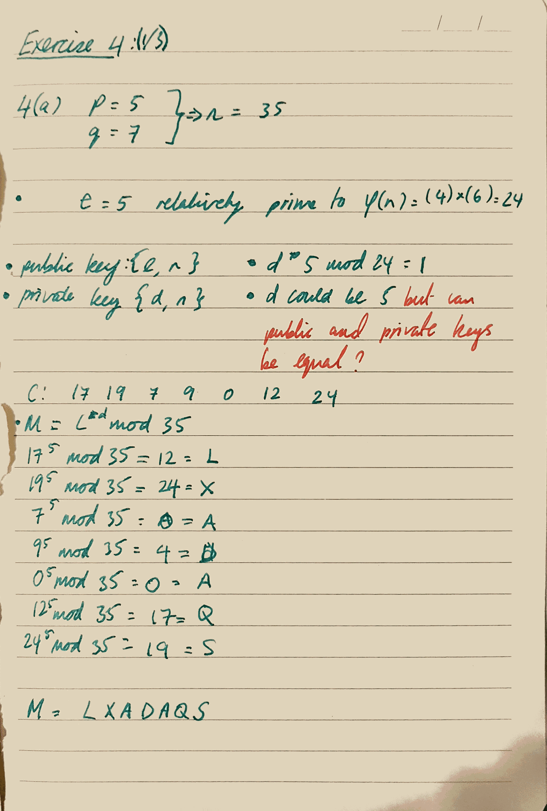(1/3)

(1/2)

Do not know how to find the encryption times for the final bit

(1/3)

Do not know how to find the key generation and the encryption times.